 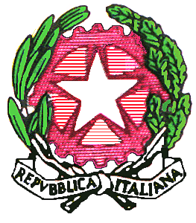 

MINISTERO DELL’ISTRUZIONE, DELL’UNIVERSITA’ E DELLA RICERCA

REGIONE SICILIANA

ISTITUTO TECNICO AERONAUTICO STATALE

*"ARTURO FERRARIN"*

# **CATANIA**

PROGRAMMA DI LINGUA INGLESE A.S. 2019/2020

CLASSE 3°

Modulo 1

Unità 1

Grammatica: Present simple, adverbs of frequency, present continuous

Letture: Identity parade, tara talks (sharing the UPS and down of my crazy studente Life),

Unità 2

Grammatica: Modal verbs can/ could/ be able to, question formation

Letture: We can be heroes!, Absolutely the best celeb quiz!, We love London, Friendship forever!, Welcome to my (temporary) new life! By Sean Woods, My favorite painting,

Modulo 2

Unità 3

Grammatica: Past simple, modal verb could, used to/ would,

Letture: Catching up, teenage life in the 70s e 80s, welcome to the 1950s!,good mobile manners,

Unità 4

Grammatica: Past continuous

Letture: Lucky escape, stuff happens, buried alive, life is one great big adventure,

Modulo 3

Unità 5

Grammatica: modal verb must, semi-modal verb have to, needn't

Letture: Sure start my holiday style, go USA,

Unità 6

Grammatica: comparatives and superlatives

Letture: survival in the USA, tara talks, Explore.Dream.Discover. ,my gap year, capital city life ,

Modulo 4

Unità 7

Grammatica: present perfect, ever/ never, for/ since

**ARGOMENTI SVOLTI NEL CORSO DELLA DIDATTICA A DISTANZA**:

How to describe a picture ,word and phrase list on picture description (PET exam)

Wish+simple past; Wish +would;wish+past perfect

Have/get something done

Usede to;be used to ;get used to

Prefissi/suffissi

By/ until

Videos: Coronavirus,World health organization, Coronavirus pandemic, Masks,BBC news- coronavirus,

Docente

Francesca Grazia Lanzafame